**Padgha Urdu High School**

**I Semester Exam October - 20**2**4**

|  |  |  |  |
| --- | --- | --- | --- |
| **Class : VII Std.** | **Subject : English** | **Total Marks : 50** | **Time :** 2 ½ **Hour** |

**Q1. [A] Answer the following questions: [ Any 5] [10 Marks]**

1. What does one have to do to prove a theory scientifically?
2. Why did the other traveller lie with his face in the dust?
3. Why did the teachers punish the students?
4. What was Yuan Chwang’s dream?
5. Why are great scientific minds restless?
6. Why did the man feel ashamed?
7. Was Raman interested in arts?

**[B]** **Guess the meaning of: [Any 6] [06 Marks]**

1) refreshment 2) bespattered 3) copycats

4) turned up his long nose- 5) horse back 6) kerchiefs-

7) put up with 8) one word brought back another

**Q2. [A] Find at least two things from the poem that show the following: [02 Marks]**

**★**The atmosphere is pleasant.

**[B] Read the following sentence and fill in the blanks: [02 Marks]**

1) The teeny- tiny woman said in her _________________ teeny tiny voice.

2) The teeny- tiny woman lived in a teeny- tiny _________________.

3) The teeny- tiny woman was awakened by a teeny- tiny _________________ from the teeny-tiny _________________.

4) The teeny-tiny woman went out to take a _________________.

**Q3. [A] Prepare a life sketch of Dr.C.V Raman based on lesson: [05 Marks]**

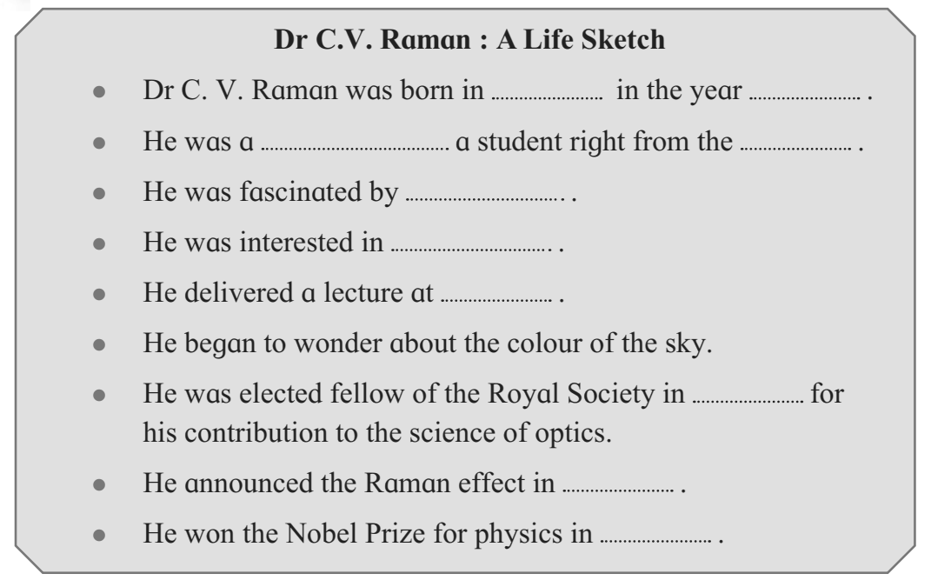

**[B] This Story has two parts. Write what happened in each part. [05 Marks]**

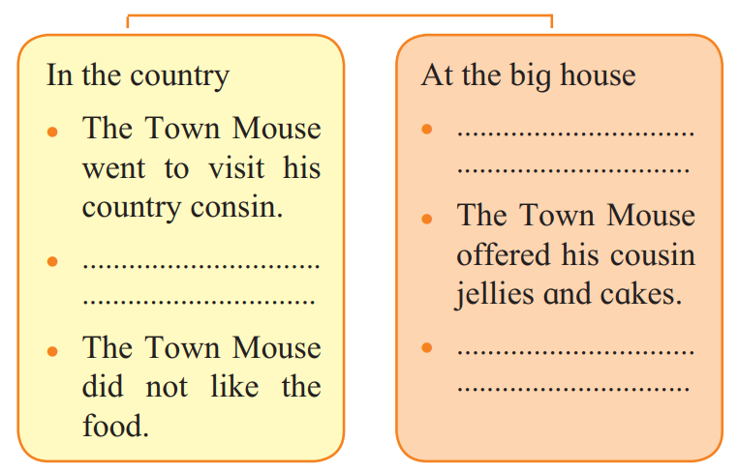

**Q4. [A] Each line in the poem tells you something about the people singing it. Read the situation in “column A” and write the appropriate line in “column B”. [03 Marks]**

|  |  |  |
| --- | --- | --- |
|  | **A] What the line tells us** | **B] The line** |
| 1. | The people singing the song have no peace today. | • |
| 2. | Other Powerful People are trying to frighten the people singing the poem | • |
| 3. | The People have to suffer many hardship today. | • |

**[B] Complete the following table. Note that these verbs have irregular past tense forms: [02 Marks]**

|  |  |  |  |  |  |
| --- | --- | --- | --- | --- | --- |
| **Past** | Went |  |  | Gave | Flew |
| **Present** | Go / Goes | Come / Comes | Eat / Eats |  | Fly / Flies |
| **Future** | Will Go |  |  |  |  |

**Q5. Letter Writing: [05 Marks]**

1. Write a application to the principal of your school requesting her to past necessary order for a study tour for the outgoing students of your class.

2. Write a letter reply regarding inability to join.

**Q6. Grammar Section:**

**[A] Write the Parts of Speech: 02**

**[B] Write the Types of Tenses: 01**

**[C] Write the forms of verbs: 02**

**[D] Identify the Parts of Speech: (Any 2) 02**

1. He is going to market.

2. I am going to bank but I will be back soon.

3. Sara is walking very fast.

4. Place the pen inside the drawer.

**[E] How many Groups are there in Irregular verbs: 01**

**[F] Write the Irregular Verbs: 02**

|  |  |  |  |
| --- | --- | --- | --- |
|  | **Base** | **Past** | **Past Participle** |
| 1. | Swim |  |  |
| 2. | Go |  |  |
| 3. | Bring |  |  |
| 4. | become |  |  |